DEGITALIZATION OF MEDICAL RECORD ADMINISTRATION SERVICES AT DIAN RAPHA MEDIKA TORAJA CLINIC

Hirman¹, Nahiruddin², Imasita³, *Nahlah⁴, Andi Gunawan⁵
^{1,2,3,4,5} Department of business administration, Politeknik Negeri Ujung Pandang, Indonesia
*Correspondence: Nahlah, Hp. 085298528482, nahlah@poliupg.ac.id

ABSTRACT
In the world of health, the management of administrative documents, especially medical records, is a very important thing to do. Management of medical records in collaboration with information technology can improve services effectively and efficiently in managing information data quickly and avoiding delays in service. Until now, the Dian Rapha Medika Toraja Clinic still uses manual medical record administration management with several existing obstacles. This causes health services that should be handled quickly cannot be carried out. Therefore, the researcher is interested and aims to design a website-based medical record administration management system at the Dian Rapha Medika Clinic Toraja. This study uses the waterfall model design method which consists of 1) Needs Analysis, 2) System Design, 3) Implementation, and 4) Testing. The data collection techniques in this design are 1) Interview and 2) Observation. The results of this study indicate several advantages when using digitization of administrative services for medical colleagues at Dian Rapha Medika Toraja clinic, namely: 1) assisting in digitally documenting patient medical record data; 2) input of patient medical record data is easier and faster; 3) facilitate doctors in analyzing the patient's medical records; 4) searching for patient medical record data is easier and faster; 5) storage of medical record data is more concise and well-structured due to the integration of patient data and medical records so that it can accelerate administrative management at the clinic.
Keywords: Website, Information System, Administration, Digital Medical Record

1. Introduction
The management of medical records in hospitals is to support the achievement of administrative order in order to achieve the goals of the hospital [1]. Good and quality medical record services can be seen from the lack of time to provide medical record files, the faster the provision of medical record files, the faster the services provided to patients [2].
The provision of outpatient medical record documents starts from the moment the patient finishes registering until the medical record file arrives at the intended poly [3].
Based on the results of the trial of the medical record information system at the Sukamerindu Health Center in Bengkulu City and the data and information that has been collected, it can be concluded that: 1. The program that is built is easy to use, does not require special skills and skills in carrying it out, 2. This program can provide convenience for Sukamerindu Public Healt Center in implementing routine patient registration service activities. No. 4]
In the Regulation of the Minister of Health No. 269/MENKES/PER/III/2008 states that the Medical Record is a file that contains records and documents about patients, examinations, treatment, actions and other services that have been provided to patients. Medical records can be used as documents containing patient health care and treatment, evidence in the law enforcement process, medical discipline and medical ethics enforcement, educational and research purposes, the basis for paying health care costs and health statistics. [5]
Clinic is a health service facility that provides individual health services that provide basic and/or specialist medical services [6]
Dian Rapha Medika Clinic is located at Jalan Nusantara No. 76 subdistrict. Makale, district. Tana Toraja. This clinic is a general clinic that serves consultations with specialists and general practitioners, laboratory examinations, heart examinations (Electrocardiogram), and general examinations (children & adults).
Based on initial observations on May 23, 2022, it was found that the management and reporting of patient data at the Dian Rapha Medika Clinic had not fully utilized current technological developments. In the process of managing patient data, they have implemented a computerized system using an Excel database as a medium for managing patient data. For making patient data reports, they still apply manual work methods, namely by writing patient data onto cardboard or paper as a patient card. By using this method, delays in service, examination and patient handling occur. Slow handling will have a bad effect on patients who will seek treatment, especially patients who come with severe, critical conditions or require rapid treatment.
Other information obtained from one of the officers who work in the administration and medical records department is that the implementation of the patient administration system and medical records still often experiences several obstacles, such as the results of medical records that are still written on the examination paper list. In addition, patient medical record files that are stored in filing cabinets often result in delays in retrieval, especially in doctor's examination services.

2. Literature Review
Administration is a collaborative process that exists in all group businesses, government or private, civil and military, large and small scale. [7]
Website is a collection of pages that contain digital data information in the form of text, images, animation, sound and video or a combination of all of them provided through an internet connection so that it can be accessed and viewed by everyone throughout Indonesia.[8]
Furthermore, a website is an application that contains pages about documents or information in the form of text, images and others on a website [9].
The meaning of the medical record itself, according to the explanation of Article 46 paragraph (1) of Law Number 29 of 2004 concerning Medical Practice is a file containing records and documents regarding patient identity, examination, treatment, action, and other services that have been provided to patients. [10]
The purpose of medical records is to support the achievement of an administrative order in improving health services in hospitals.” Orderly administration is one of the determining factors in the efforts of health services in hospitals. Without a good and correct medical record management system, there will not be an orderly hospital administration as expected [11].

3. Method
This research was conducted at the Dian Rapha Medika Clinic, which is located in Jalan Nusantara No. 76 subdistrict. Makale, district. Tana Toraja.
The method used is the Waterfall model method with the following stages:

a). Requirement (Need Analysis)
b). Design (System Design/Design)
Website design is done in order to make it easier to build the system later, so that the description made is clear about its goals and objectives

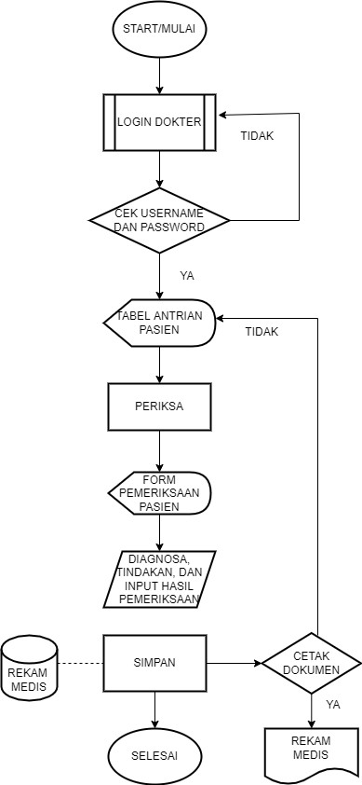
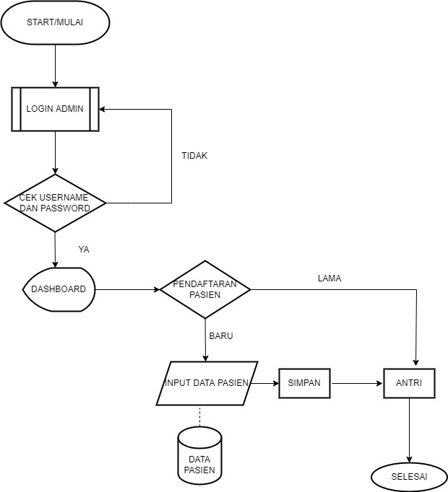
- Flowchart Admin System b. Flowchart Doctor System

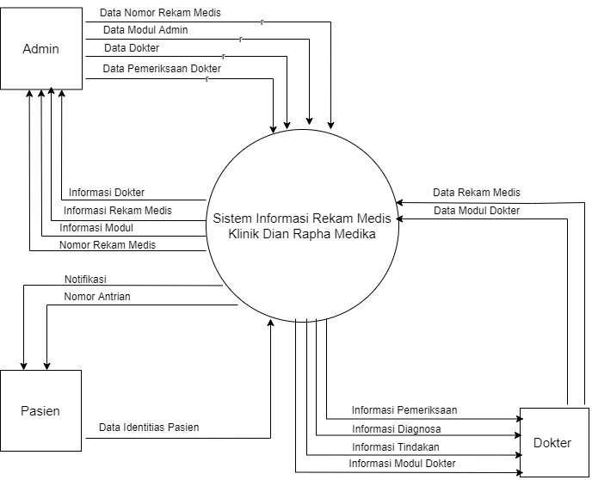
Fig. 1 Flowchart Admin System Fig. 2 Flowchart Doctor System

Fig. 3 Context Diagram of Medical Record Information System

d) Diagram Activity
(1) Diagram Activity (Conventional Process) (2) Diagram Activity (Running System)
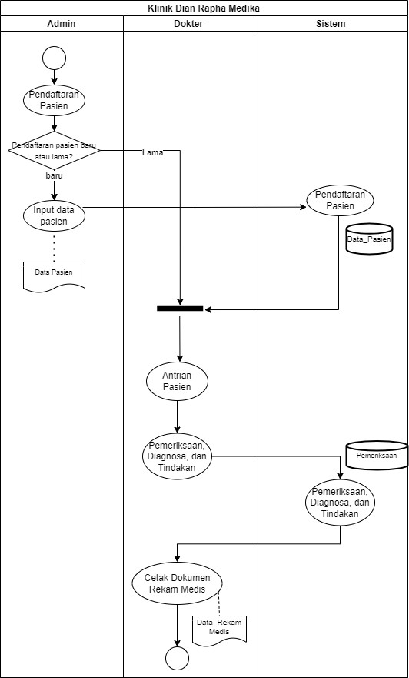
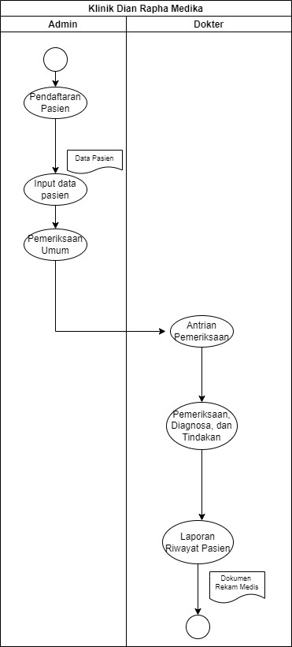

Fig 4. Diagram Activity: Conventional Process and Running System

3). Implementation
Implementation is the process of implementing an Information system that has been designed with the aim of simplifying the process of managing medical record administration at the Dian Rapha Medika Toraja Clinic.

4). Testing
After the system design is complete, then further testing is carried out on the results of the design. At this stage, the system is checked to see whether it can function properly or if there are errors, such as errors, so that it is in accordance with the use of the system and can meet the results to be achieved.

4. Results and Discussion

Degitalization of Medical Record Administration Services at Dian Rapha Medika Clinic Toraja
This application has several menus, namely:
1). Login page
This page is intended for 2 users, namely admins and doctors. Each with a different username and password.
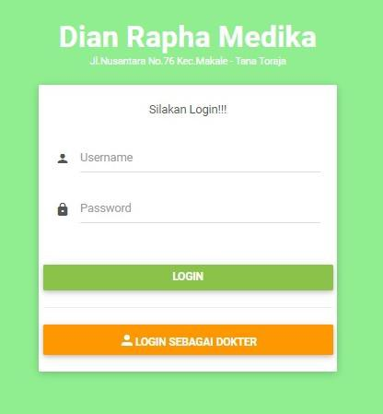

Fig 5. Login Page View
2). Dashboard
This menu is a visual display of data information that is centered on one website page that contains information from the database. The dashboard display on the stem side contains information on the number of patient data, the number of doctors, the number of medical record documents, the number of patients who have registered, and the patient queue list. The dashboard display on the system is divided into 2, namely the dashboard for admin and doctor, like the picture below:
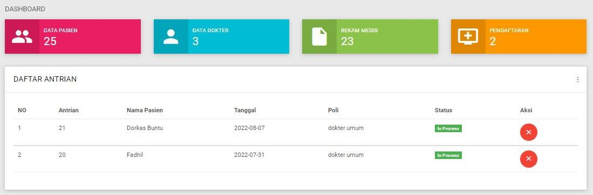

Fig 6. Admin Dashboard
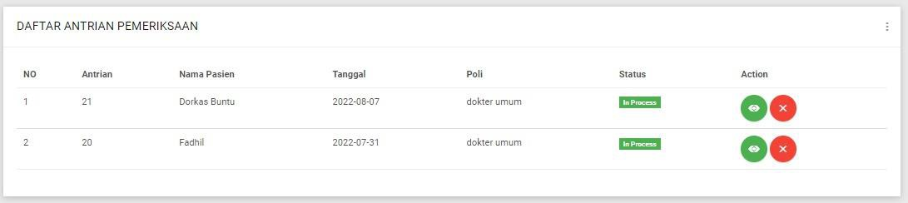

Fig 7. Doctor Dashboard View

3). Sidebar menu
Sidebar is a column that is usually located on the side or side of a website page that contains additional menus or navigation. The sidebar display in this system is made based on the level of the user in accessing the website. The user level on this website is divided into two, namely the admin user and the doctor user.

a) Sidebar Admin b) Sidebar Doctor
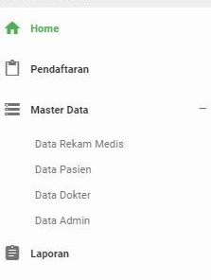

Fig 8. Sidebar Admin View Fig 9. View Sidebar Doctor
4). Patient Registration Menu
The patient registration menu consists of 2 parts, namely the patient registration form and the patient data search menu.
a. Patient Registration Form

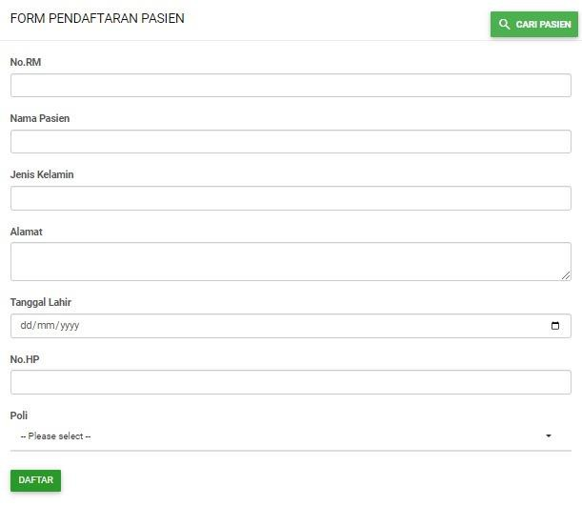

Fig 10. Display of Patient Registration Form

b. Patient Data Search Menu
This form is intended for admins and doctors to search for patient data that has been registered in the system. The contents of the patient data search menu are as follows:

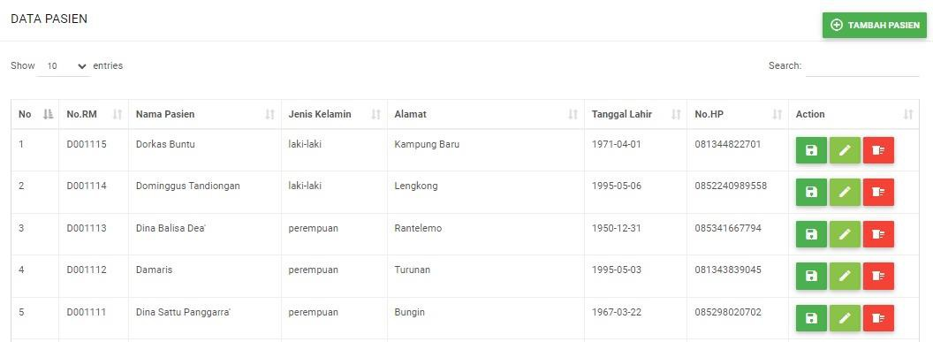

Fig 11. Display of Patient Data Search Menu

5). Patient Data Menu
The patient data menu is used to display information on patient data who are undergoing treatment at the Dian Rapha Medika Toraja Clinic. The patient identity information in this menu is equipped with additional action buttons such as save, edit, and delete as follows:

Figure 12. Patient Data Menu

6). Doctor Data Menu
The doctor data menu is used to display information on the official identity data of doctors who are registered to work at the Dian Rapha Medika Toraja Clinic. The doctor data menu consists of 2 parts, namely doctor data and a doctor data registration form.
- Doctor Data
The doctor's identity information will be displayed in this menu and equipped with additional action buttons such as view, edit, and delete as follows:

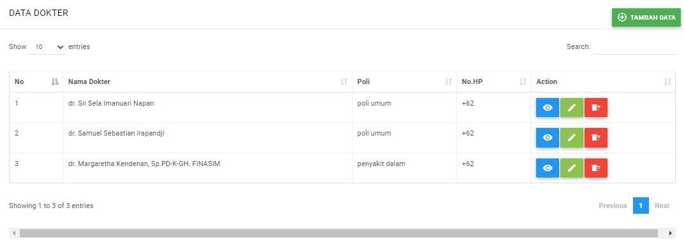

Figure 13. Display of Doctor Data Menu

7). Medical Record Data Menu
The medical record data menu is used to display data information on the results of medical examinations of patients who have undergone treatment at the Dian Rapha Medika Toraja Clinic. In the medical record data menu, it is divided into several facilities, namely medical record data and the form for adding medical record data.
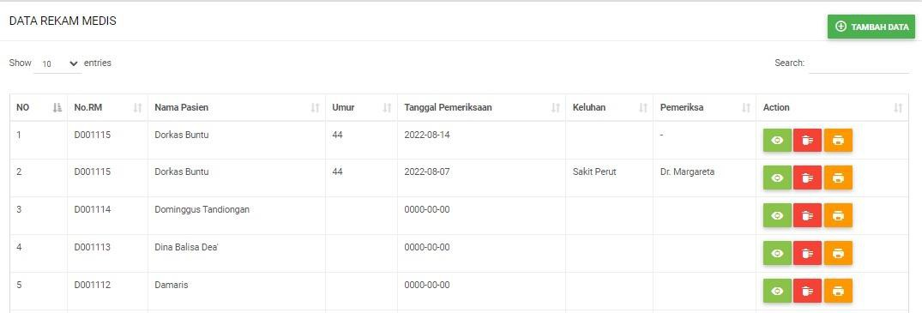

Figure 14. Display of Medical Record Data Menu
Figure above is equipped with an action button that functions to display and, at the same time, update medical record data consisting of basic examination data and doctor's examinations from patients who have performed examinations. The following is a display of the contents of the view action button:
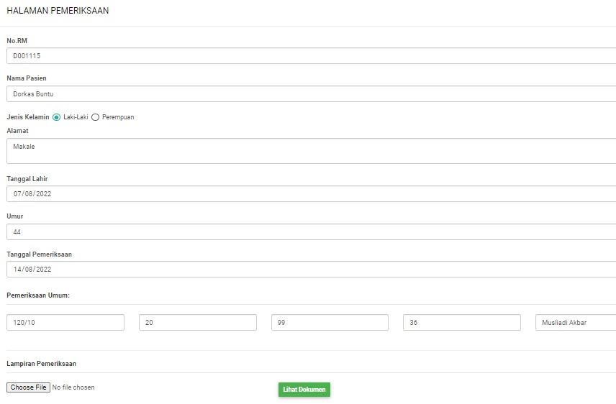

Figure 15. Basic Inspection Page Display

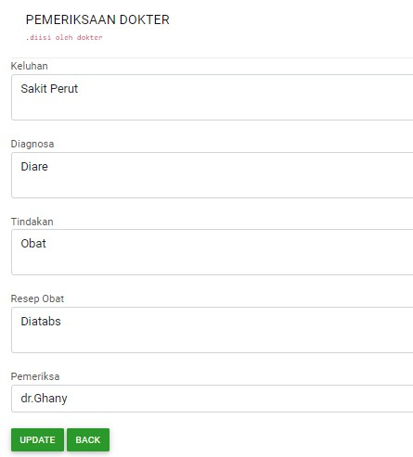

Figure 16. Doctor's Examination Page Display

8). Patient Visit Report Menu
The patient visit report menu is used to display patient visit report information at the Dian Rapha Medika Toraja Clinic specifically using the visit time range accompanied by the name of the patient you want to find.

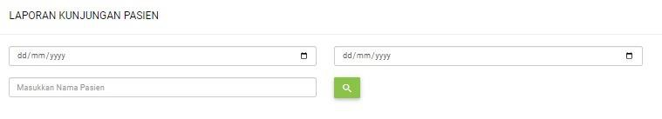

Figure 17. Display of Patient Visit Report Menu

Admin only needs to enter the start and end date of the search. Next, fill in the name of the patient you want to find. For example, when searching for a patient's visit history on behalf of Dorkas Buntu with a time range from August 1, 2022 - August 8, 2022.
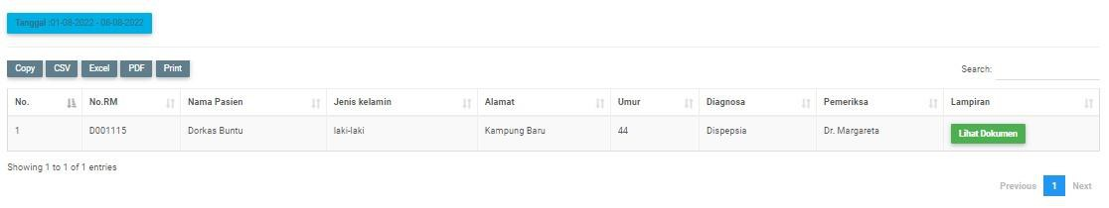

Figure 18. Display of Patient Visit History Results

The results showed that the patient on behalf of Dorkas Buntu received 1x treatment from August 1, 2022 – August 8, 2022.
The report on the history of the patient's visit is also accompanied by a document attachment that will display the patient's health file from the clinic.

5. Conclusion
From the results of the analysis of the digitalization of medical record administration services at the Dian Rapha Medika Toraja clinic, it can be concluded that: 1) assisting in digitally documenting the patient's medical record data. 2) By using this application, the process of inputting patient medical record data is easier and faster. 3) Make it easier for doctors to analyze patient medical records, 4) search for patient medical record data more easily and quickly, 5) medical record data storage is more concise and well-structured because of the integration of patient data and medical records so that it can accelerate administrative management at the clinic.

Funding: Please add: “This research received no external funding” or “This research was funded by NAME OF FUNDER, grant number XXX” and “The APC was funded by XXX”.
Conflicts of Interest: Declare conflicts of interest or state “The authors declare no conflict of interest.”
ORCID iD (if any)
Author Contribution : All the authors have read and agreed with the published version of this paper. All authors contributed to the article and approved the submitted version.
Publisher’s Note: All claims expressed in this article are solely those of the authors and do not necessarily represent those of their affiliated organizations, or those of the publisher, the editors and the reviewers.
Ethical approval
Authors are required to state whether ehical approval was sought or not for the present study especially if the study is a clinical trial or animal experiment.
Informed consent
Authors are required to state whether participants provided informed consent and whether the consent was written or verbal.

REFERENCES
- JURNAL KESEHATAN MASYARAKAT, Volume 1, Nomor 2, Tahun 2012, Halaman 48 - 61 Online di http://ejournals1.undip.ac.id/index.php/jkm Frenti Giyana
- Abdullah, 2013 J-REMI : Jurnal Rekam Medik Dan Informasi Kesehatan E-ISSN: 2721-866X Vol. 1 No. 4, September 2020
- J-REMI: Jurnal Rekam Medik Dan Informasi Kesehatan E-ISSN: 2721-866X Vol. 1 No. 4, September 2020 Astrid Kartika Dewi Aprilia1, Ida Nurmawati2, Rossalina Adi Wijayanti.
- Cahyanti, Ana Nur. (2012). Pembangunan Sistem Informasi Manajemen Puskesmas PakisBaru Nawangan. Journal Speed Volume 4 No. 4 Buliali, Joko.
- Peraturan Menteri Kesehatan No.269/MENKES/PER/III/2008 tentang rekam medis
- Peraturan Pemerintah Kesehatan Republic Indonesia Nomor 9 Tahun 2014 tentang Klinik.
7. Indra Muchlis Adnan, S. H. (2013). Administrasi, Organisasi, dan Manajemen, Suatu Ilmu, Teori, Konsep dan Aplikasi. Daerah Istimewa Yogyakarta: Trussmedia Grafika.
8 Abduloh, R. (2018). 7 In 1 Pemrograman WEB untuk pemula, cara cepat dan efektif menjadi web Programmer. Jawa Tengah: PT Elex Media Komputindo.
9. Wicaksono, D. A., Rawansyah, & Ed Dien, H. (2021). Rancang Bangun E-Commerce Berbasis Web Menggunakan PHP dan MySQL di CV. Sumber Raya Jember. Seminar Informatika Aplikatif Polinema (SIAP), 6-13.
10. Undang- Undang Nomor 29 Tahun 2004 tentang praktek kedokteran
11. Departemen Kesehatan Republik Indonesia (Depkes RI) Tahun 2006 Pedoman Manajemen Sumber Daya Manusia (Sdm) Kesehatan Dalam Penanggulangan Bencana

